Hua Hin H3 Run #299 – 7th February 2015

Location: Left off the by-pass (Route 37) just past the 13 km marker
Google Map link: https://goo.gl/maps/Cc4c
GPS Coordinates: N 12.703594, E 99.915997 (N 12 42.216, E 99 54.960)
Hares: Donkey Cock & Quick Mickey Mou
Hash Snacks: Doggie Style
Hash Notes: Jock Twat
Hash Photos: Dazzlin’ Maslin & Loose Screw
Number of Hashers: 63

Pre-Hash
The assembled throng gathered at the car park, where luckily no one had brought a cat, as there wasn’t enough room to swing one. This band of happy hashers had been brought together in search of fresh air, camaraderie, exercise and above all the ‘ale at the end of the trail’
Mickey Mou gave the pre-run brief in his own inimitable style, demonstrating to all and sundry how to lay a trail across a circle, should the need ever arise. With his assurance that there were no rabid canines, stampeding bovines or barbed wire the like not seen since the First World War, the On On was pointed out.
The Trail
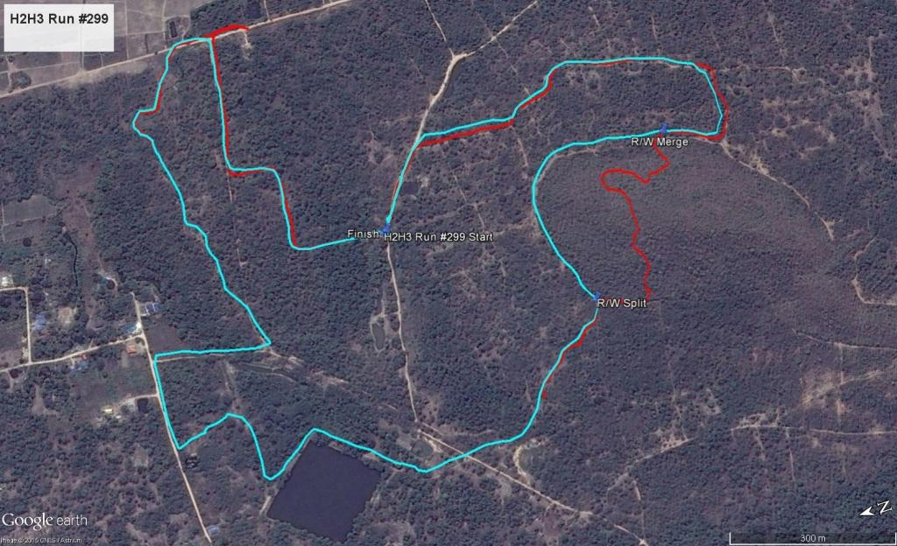
The runners/walkers/crawlers proceeded in a Northerly-ish direction and were soon ensconced in woodland. The trail was hampered by the usual checks, and just a ‘few’ false trails, in fact there were more falsies than a Lady Boy bar in Nana Plaza. Butt Out & Screwdriver managed to navigate every false trail to the bitter end, with the pack at their heels, the pack will follow these two trailblazers anywhere, not because of their ability to find the trail, no, more out of a sense of morbid curiosity.
The route meandered through the trees with a nice lake making an appearance. Hash Flash kept popping up in front of the pack and flashing, Short Cutting B******? The walkers trail was 4.7 km with the runners’ loop of 0.7km (ED although this did not add to distance only to time); route went in an anti-clockwise direction. With the false trails and checks the pack more or less stuck together, good job by the hares. Donkey Cock & Mickey Mou had no more devious schemes up their vests to make our lives that bit harder. All in all, it was decided that it was a very good run.
First past the post for the runners was that ‘Tough of the Track’ Mudman, for the walkers it was our pathfinder duo Butt Out & Screwdriver joined at the hip, although Screwdriver had to break into a lolloping gait to keep up with B.O. some unkind souls said the burst of speed was a ‘Leo rush’
Post Trail and Circle
With the thirsty hashers descending on the beer truck and being suitably imbibed, Hash Snacks were provided by Doggie Style, with these delicious tit-bits she will defiantly ‘Winnalot’ of ‘Chums’ well done DS.
The circle was called promptly at 18:17 and a few seconds. Down downs were bestowed upon the Hares and Hash Snacks. The bunch of miscreant returnees, Bend Over, Cannon Ball, Has-Bean Counter Warm Piss & Long Ron were also rewarded with a down down (rewarded? It’s Chang for god’s sake!). Two visitors Bob & Nancy were exposed because they didn’t use their hash names. It was discovered that Nancy’s handle was ‘’Hanaho’’ which apparently is Hawaiian for ‘’I want more’’ Bob’s moniker is ‘‘Kamoniwannalaya’’ hmmm; I think I would sit that one out also!
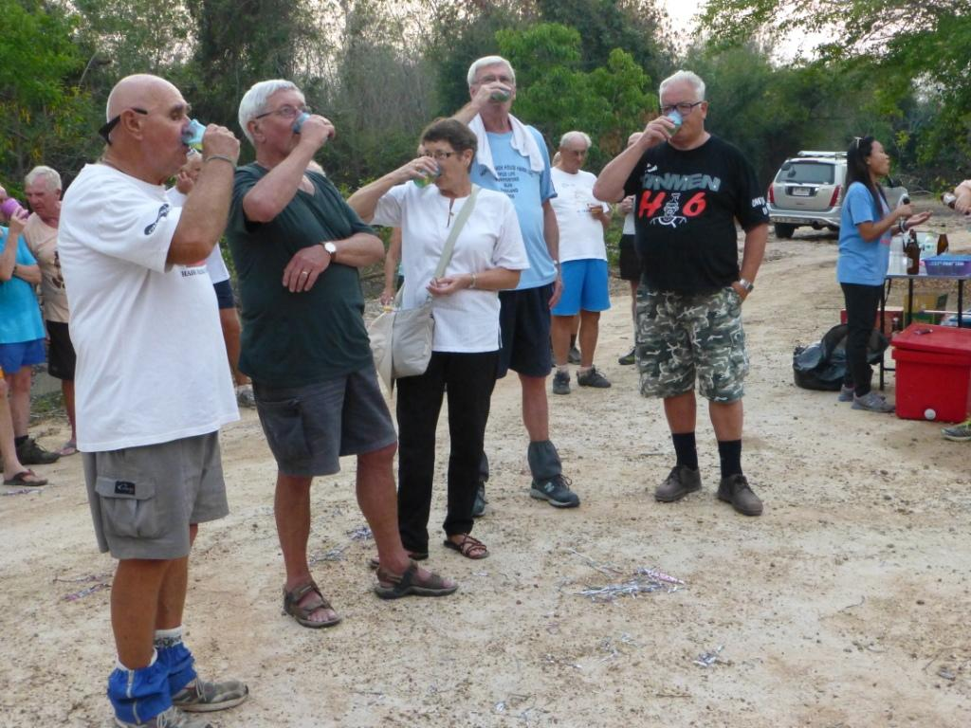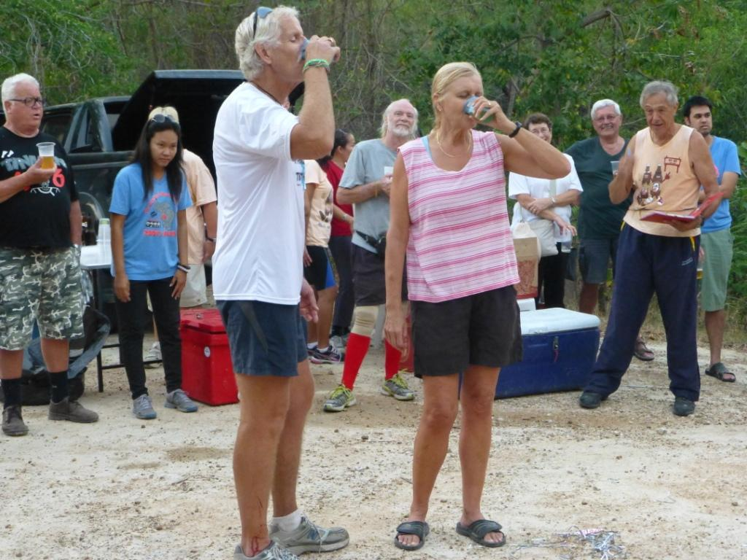
Hash christenings were now the order of the day.
Joe was stitched up by his mates with the hash name ‘Lady Boy Slayer’ why? All will be revealed, or maybe it already has been revealed to Joe! Also Hans was named by his mates ‘Hans on Dick’ something to do with having a naval background in the family.
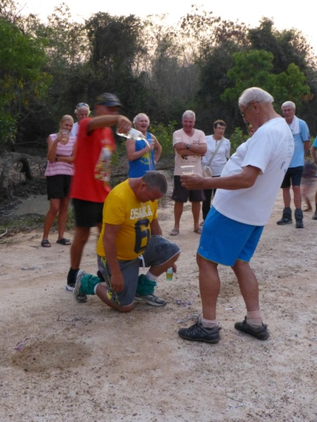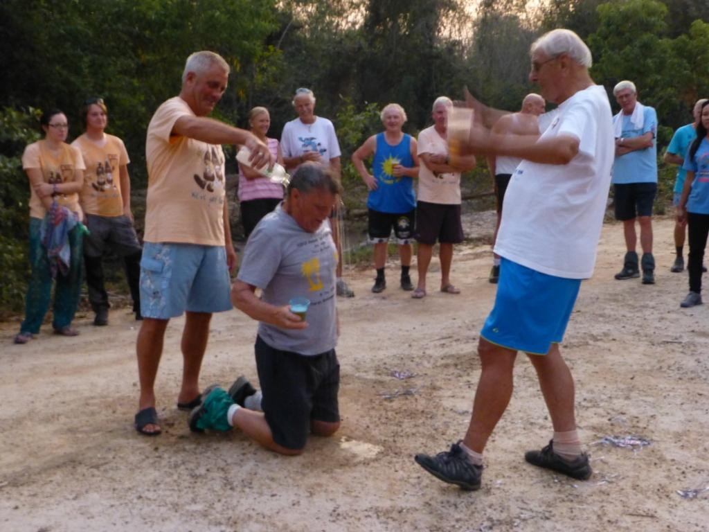
Next in front of the baying mob were Old MacDonald’s grand-daughter Ann & her friend Jamie. Now these two nice young people are instructors for an outward bound school in the perma-frost of Scotlandshire, so they are used to mountains and stuff. Jamie’s hash name? Had to be ‘Ben Doon’ and Ann’s? Fill McCrakin, oh! How we laughed!
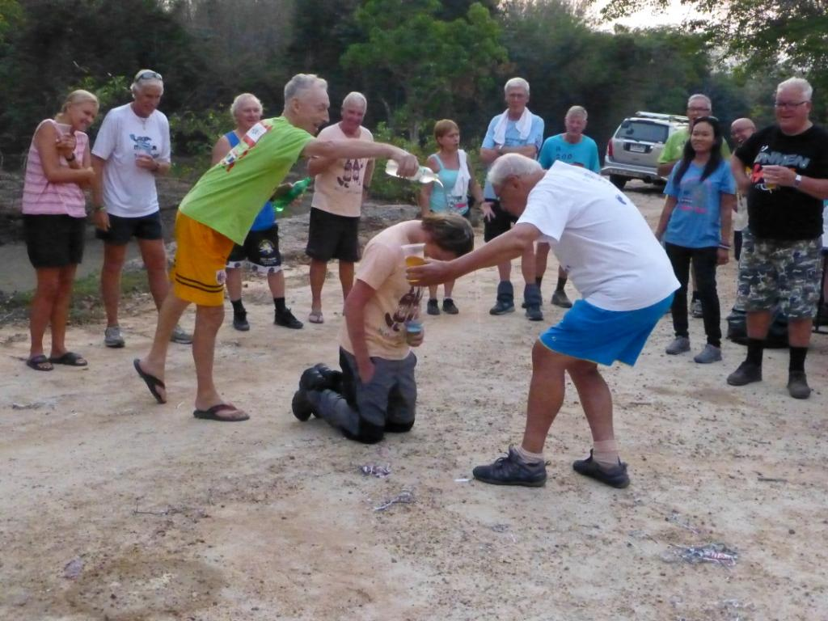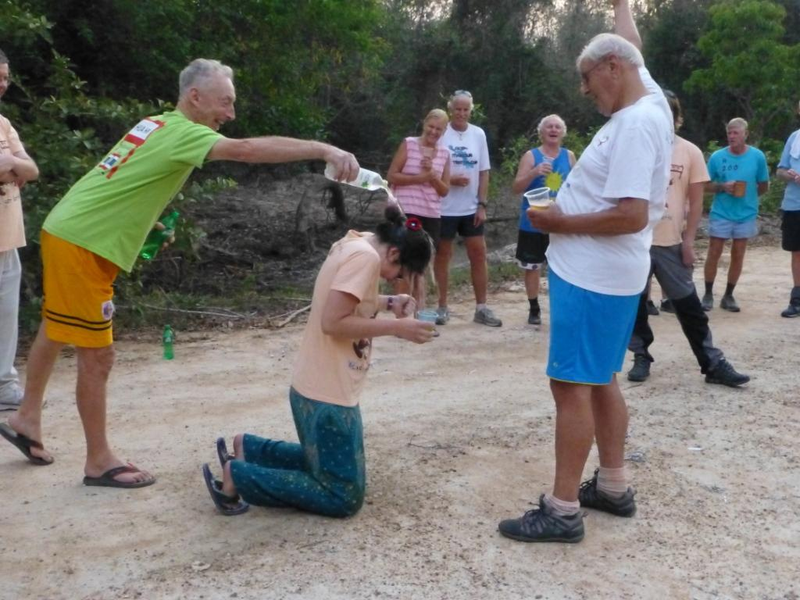
Mudman was next in front of the frenzied crowd for a down down. His heinous crime? Forgetting to pay his hash subs to the GM. In his defense, MM did say that ‘’As he runs so fast around the route, he hardly spends any time at all on the trail, also as he drinks Chang this does not constitute real beer, so no need to pay’’
The Hares were once again summoned into the circle for a down down to explain the absence of shredded paper on a section of the trail. Obviously each one blamed the other, handbags at dawn scenario, intrepid hares? More like Berke & Hare.
Circle was adjourned at dark o’clock.
Next week’s Cha Am Hash is the 250th run, location to be announced on the website.
On On
Jock Twat
