Hua Hin H3 Run #288 – 20th September 2014

Location: Off the Springfield Road (Route 1001)
Google Map link: https://goo.gl/maps/mgrou
GPS Coordinates: N 12.734027, E 99.849027 (N 12 44.042 E 99 50.942)
Hares: Hugmanannygoat & Pick Lick Roll & Flick
Snacks: Tinks
Hash Notes: Cathusalem
Hash Photos: Ballbanger (can be found on the website http://www.h2h3-cah3.com/hash-trash1)
Number of Hashers: 47

Third and Final of the Hugmanannygoat and PLR&F Hash Trilogy
With two previous visits to the same venue in recent weeks, the car practically drove itself there. There were superb views as we drove along the crest of the dam in bright sunshine but it was hot when we arrived and got out of the car. The usual suspects were already there with just a few latecomers still to arrive, notably two female virgins on a motor bike.
Tinks called the circle and, having welcomed the virgins, invited the hares to tell us what they had in store for us. PLR&F told us everyone would have some uphill today, which was not unexpected. He went on to say that there was a shorter trail available. This prompted someone to ask whether that meant there was a shorter option on the walkers trail. However, PLR&F responded to say that there were only two trails and that the runner /walker split would be after about 2.5 km.
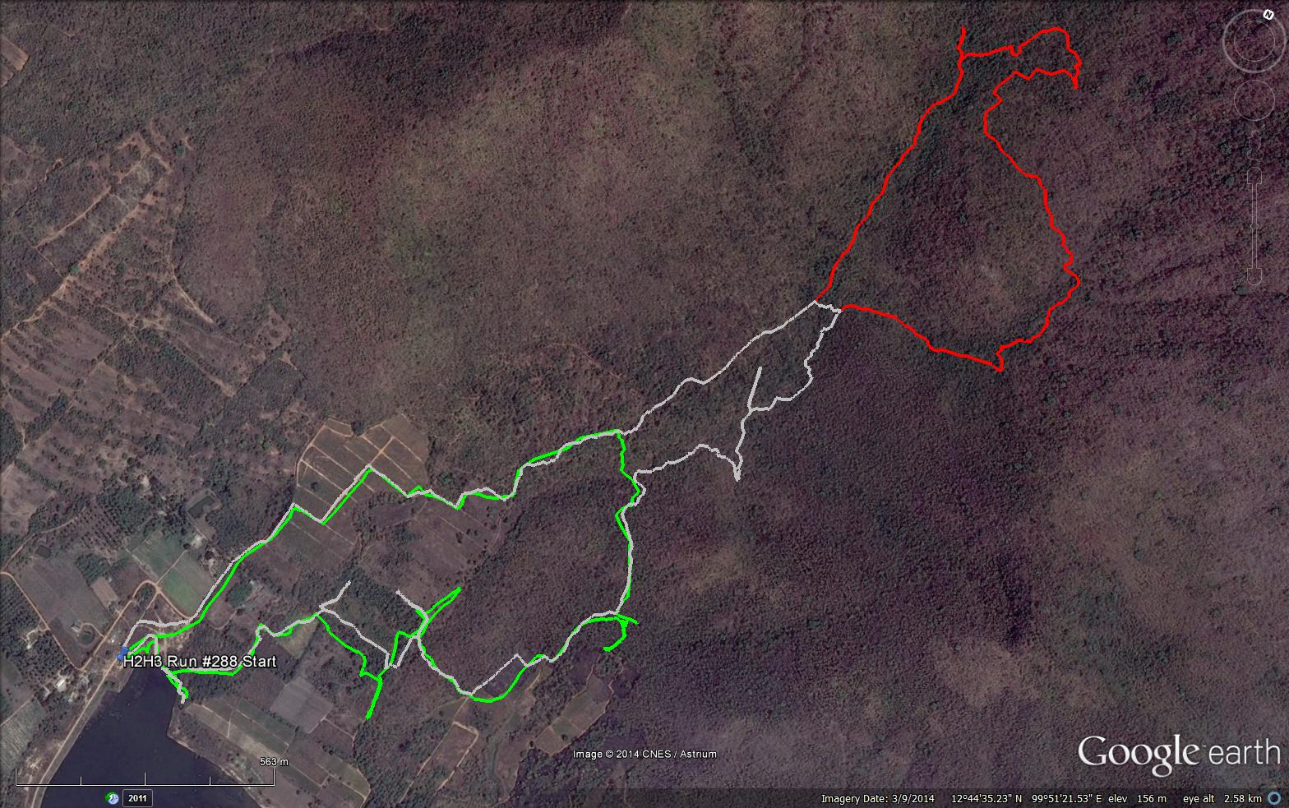
So off we went in single file picking our way through small bushes with plenty of paper to guide us…see feature photo. We didn’t have time to admire the view though. After a check, we had the doubtful pleasure of a double false trail and this was how it happened. The trail turned sharp left up a short steep slope but everybody missed it and carried on just following somebody in front before it was realised there was no paper. The hare then directed us back on to paper and up the short steep slope, only to find, after a further short distance, that it was a false trail. So, on the advice of PLR&F at the circle, we had to go back to the check which meant back down the steep slope and back to the check, which had been broken but I suspect some front runners either missed (or ignored) the false trail sign, carried on and found the real trail without going back to the check.
The next part of the trail was quite a long stretch along a narrow path that was obviously also a water course during heavy rainfall as it was strewn with football size boulders and I found this quite tough going. After a check and another false trail, it was uphill through the woods, more to my liking. After another 3 or 4 checks, which kept us (the walkers pack) together very well, we started to wonder how much farther to the split.
It seemed we had already covered a good 2.5 km. A female virgin told me that we had been told that the split would be after crossing a brook. I didn’t hear that I told her but now realise perhaps why she had listened more carefully than I did….thinking her life might depend on it!
Sure enough, PLR&F lead us down to a brook and back up the hillside opposite. He had to admit to being a little disorientated at this point and seemed surprised when we came to yet another check complete with a false trail. After finding the real trail, we came across PRL&F blocking our way to the split sign. He wanted to make sure that no misguided soul would attempt the runners trail which he knew was an extra 2.7 km and we had already been out 45 minutes, the slow progress being down to solving 7 checks, 4 of them with false trails, the latter being the main reason for the particularly slow progress according to this scribe’s viewpoint.
So what was Hugmanannygoat doing all this time? Well, it seemed that he’d done a lot of work earlier that day, in the high altitude of the runners trail, so PLR&F had taken on the on-trail sweeping by himself. Hugmanannygoat was waiting at the car park to welcome the front runners but he didn’t expect them to get back so soon…in 45 minutes! Somehow, they had short cut to the in-trail around the second check before the split sign. So there was a shorter option on the walkers trail, which someone had asked about at the circle…. but it was taken by the runners instead. Poor Hugmanannygoat had done all that high altitude work on the runners trail for nothing…..and PLR&F had prevented this misguided soul from having a crack at it. “Just follow the trail to the left and within about 50 m, you’ll see the R W merge sign and after that it’s easy going” were PLR&F’s words to us as he blocked our way. True enough, the trail was much easier from that point but that didn’t stop Merrydick’s younger son taking a tumble maybe trying to outrun his elder brother.
The down-downs were as follows
Hares: Hugs & PLR&F
Poor Paper trail: PLR&F
Ice Man: Space Cowboy
Snacks: Tinks + Maggie for unfair comment on snacks
Returners: Ann, Quick Mickey, Slow Minnie, Tin Tin
Virgins: Michelle, Neisher, Pamela, Bukhard & Op
Lost & Found – Chairs left behind at last Hash – Ballbanger on behalf of Lumbering Jack
Visitors: Bill and Will (MerryDicks Sons)
My thought, on reflection, is perhaps that the hares should have been given an extra down-down as over-achievers. There is always a thin dividing line that can so easily be crossed and so easily punished. Nevertheless, Hugmanannygoat and PLR&F have done a great job in opening up this new territory. Let’s have another Trilogy soon!
On the way to the On On On, I discovered my car key was missing. I was sure it had slipped out of my shorts as I changed and that it would be on the ground. We went back and found the usual suspects still there. They helped me look but couldn’t find it so off to the Thai Kitchen for the usual bonhomie….regardless.
I went out early next morning and found my car key. I had a bit of luck to help me locate the spot where it fell out of my shorts while changing. I was pacing up and down and spotted a crumpled up slip of paper. Could this be Comes With Cathusalem's phone top-up slip? Checking the time on the slip, it certainly fitted so that narrowed my search. I found the key half hidden in undergrowth.....not surprising we couldn't find it in the dark the previous night.
So from now on I will carry the car key on a lanyard around my neck, which is what I used to do but just got out of the habit.
I had remembered Ballbanger words “There's really no excuse for not bringing the correct change with so many 7-Elevens around." So that's why we had the top-up slip.... to assist Tinks on this occasion.
On On,
Cathusalem

